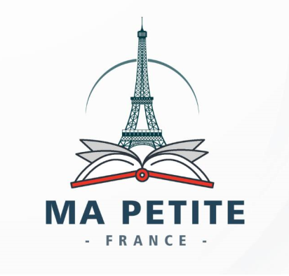 | MA PETITE FRANCE  Bookstore- Distributor-Tutors  21,kudirat Abiola way, Oregun,Lagos  Info@mapetitefranceng.com  www.mapetitefranceng.com

TUTOR REQUEST FORM (SCHOOL)

Institution’s Information
Name of School:

Address:

Phone Number: |  | Alternate Phone:

Email

Lecture Information
Total number of Student(s)

Number of classes to be taught |  |  | Lecture hours
Total number of requested Tutors |  |  | Lecture Days
Preferred Start Date

MERCI POUR AVOIR CHOISI M.P.F

